NAME: VENKATRAMAMOORTHY.G
- Change text of an element using getElementById.
CODE:
<!DOCTYPE html>
<html lang="en">
<head>
<meta charset="UTF-8">
<meta name="viewport" content="width=device-width, initial-scale=1.0">
<title>Document</title>
</head>
<body>
<h1 id="text">hello world</h1>
<button onclick="change()">click to change text</button>
<script>
function change(){
document.getElementById('text').innerText="text changed";
}
</script>
</body>
</html>
OUTPUT:
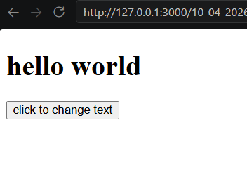
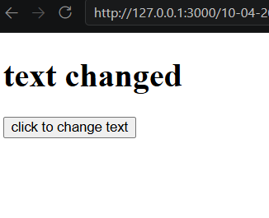
- Select an element and change its style
CODE:
<!DOCTYPE html>
<html lang="en">
<head>
<meta charset="UTF-8">
<meta name="viewport" content="width=device-width, initial-scale=1.0">
<title>Document</title>
</head>
<body>
<h1 id="text">hello world</h1>
<button onclick="change()">click to change text</button>
<script>
function change(){
document.getElementById('text').style="background-color:red";
}
</script>
</body>
</html>
OUTPUT:
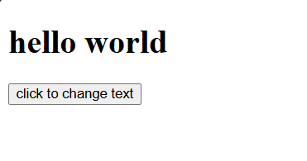
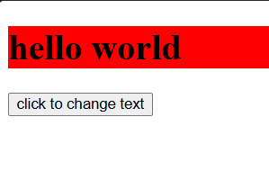
- Change content of a paragraph.
CODE:
<!DOCTYPE html>
<html lang="en">
<head>
<meta charset="UTF-8">
<meta name="viewport" content="width=device-width, initial-scale=1.0">
<title>Document</title>
</head>
<body>
<p id="text">hello world</p>
<button onclick="change()">click to change text</button>
<script>
function change(){
document.getElementById('text').innerHTML="New Paragraph Content!";
}
</script>
</body>
</html>
OUTPUT:
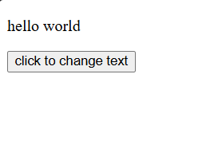
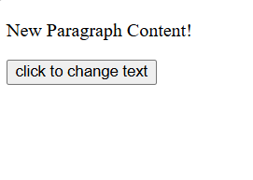
- Change color and font size of text.
CODE:
<!DOCTYPE html>
<html lang="en">
<head>
<meta charset="UTF-8">
<meta name="viewport" content="width=device-width, initial-scale=1.0">
<title>Document</title>
</head>
<body>
<p id="text">hello world</p>
<button onclick="change()">click to change text</button>
<script>
function change(){
let a=document.getElementById('text');
a.style.color='blue';
a.style.fontSize='30px';
}
</script>
</body>
</html>
OUTPUT:
